**1. Introduction**

## 1.1 Purpose

The purpose of this project is to create a web application wherein user can create a music room for playing songs. It also have d

## 1.2 Project Description

We have developed a music web application where users can login and listen to their favorite songs. Here a user can create his/her own room and include the list of his favorite songs. Inside every room there will be a chat box where the group of users within that particular room can have social discussion. The user who creates the room will have the option of pausing/playing the song at any time. Since there can be large number of rooms on the homepage we have included the option of search button to make it easy for the user to select a particular room.

## 1.3 Document Scope

This document describes the main functionalities of our music web application. It also includes the list of technologies used and configuration settings required in order to run the application.

# General Overview

## Technologies used:

The following are the list of technologies we used to build our web application:

* jQuery ( library for client side scripting )
* Socket.io
* Node.js and Express 4.0 (server side scripting)
* MongoDB (data store)
* Materialize CSS (CSS framework)
* HTML

## Functionalities:

The following are the major system functionalities:

* Register a new user on our website
* Allow users to create rooms with list of their favorite songs
* Allow the authorized users to chat inside the room
* Search box on the homepage to search a room by its name
* Play and pause option for the admin of the room
* Upload songs by the users from their local drive.

**2.3 Setup Instruction:**

* Download the code from github url **https://github.com/karthik006/savtrack**
* Node.js, NPM and MONGO db are a pre requisite for this project, Make sure It is installed.
* Type the command **npm install** from the parent directory to get things started.

# Running the application:

* Type the command **npm start** from the working directory to launch the server
* The current default port number is set to 3000([https://localhost/3000)](https://localhost/3000)
* Once logged in click on **Create room** button to generate new room
* Click on upload songs button to upload songs to your created room
* Currently there are a set of default songs that is loaded statically from the server’s audio folder • To check the Functionality :
* Step1: Open two different instances of the browser. Login as two different users
* Step2: After login, let one user (User A) create a room and the other user(User B) on the other instance(other browser) click on the room created by User A.
* Step3: Now when user A plays/pause the song, we can see the Audio control plays/pause the song in User B.
* Repeat the same steps to see the chat application working

# Screenshots of the Application:

**Homepage:**

This page by default will have list of rooms which already exists, it has an option of search, sign up and login.

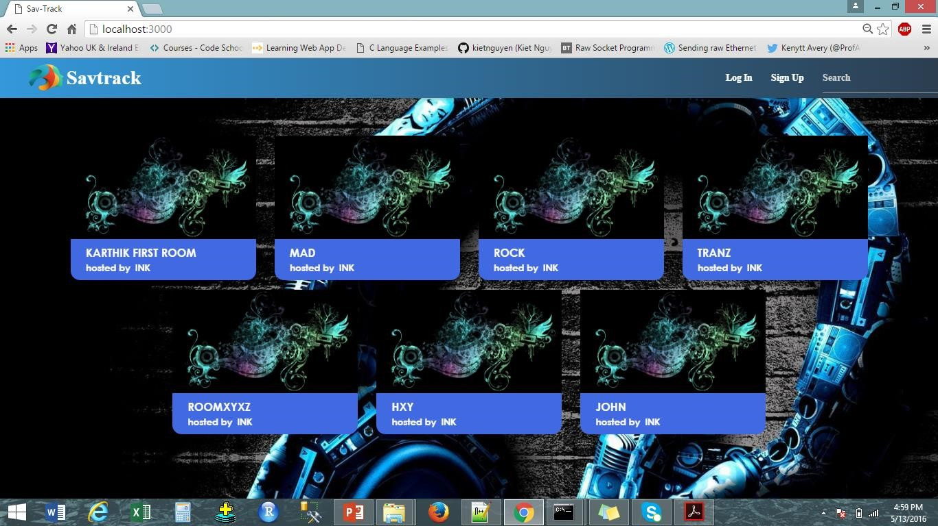

**Login page:**

This is the login page for the application, as shown in the screenshot user “ink” is trying to login.

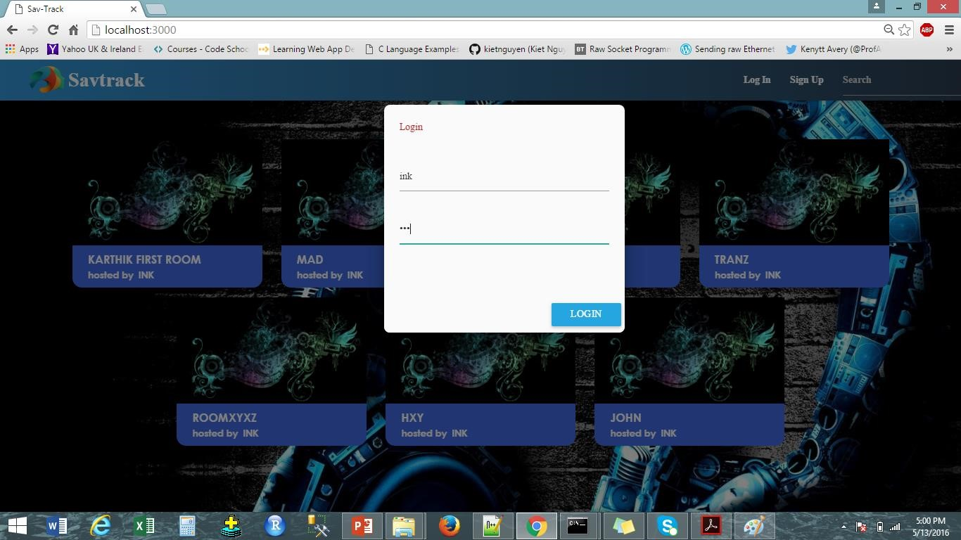

**Sign up page:**

A new user has to sign up by clicking on the signup option. As shown in the screenshot new user “sarthak” is trying to sign up.

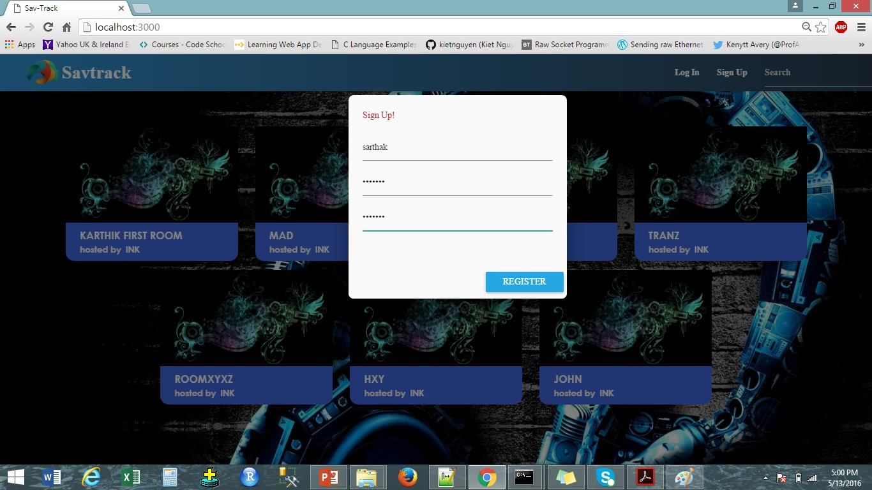

**Create Room after Login:**

User can create a new room after logging in.

**Room page**

4.5

Sea

rch box on homepage to search the rooms:

4.6

Real

-

time chat window

updates on different clients using socket.io:

4.7

Datastore on MongoDB

:

4.2.5:

Upload songs functionality

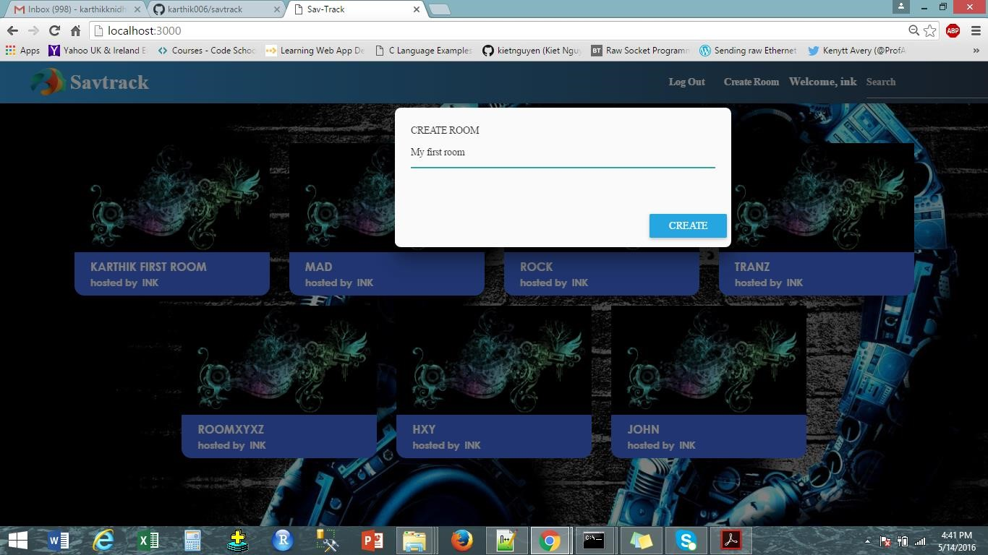

**After creating room:**

This is a page after creating the room, songs are on the left side and chat room is on the right.

**Song upload functionality**

4.2.6 :

Real

-

time chat application

4.2.7 :

Current

-

song played in the

queue, When the user is in another room

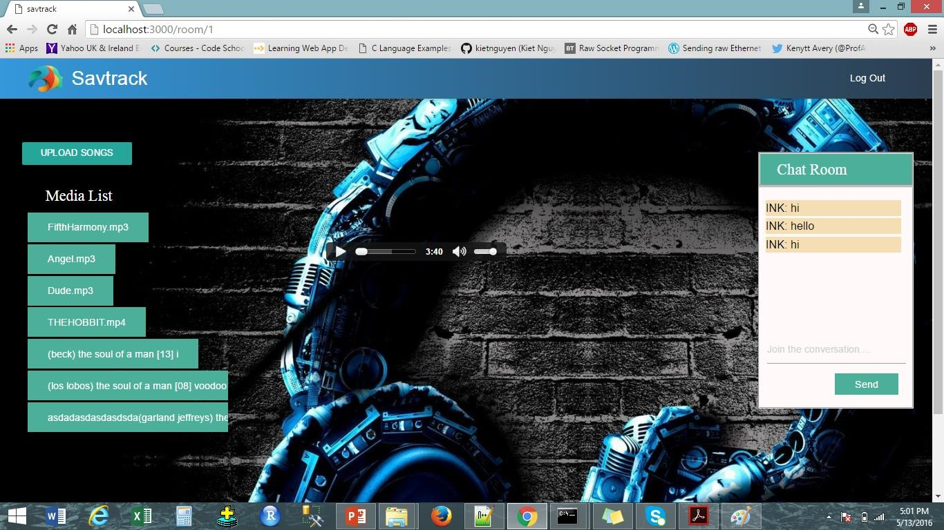

**Client side Search box**

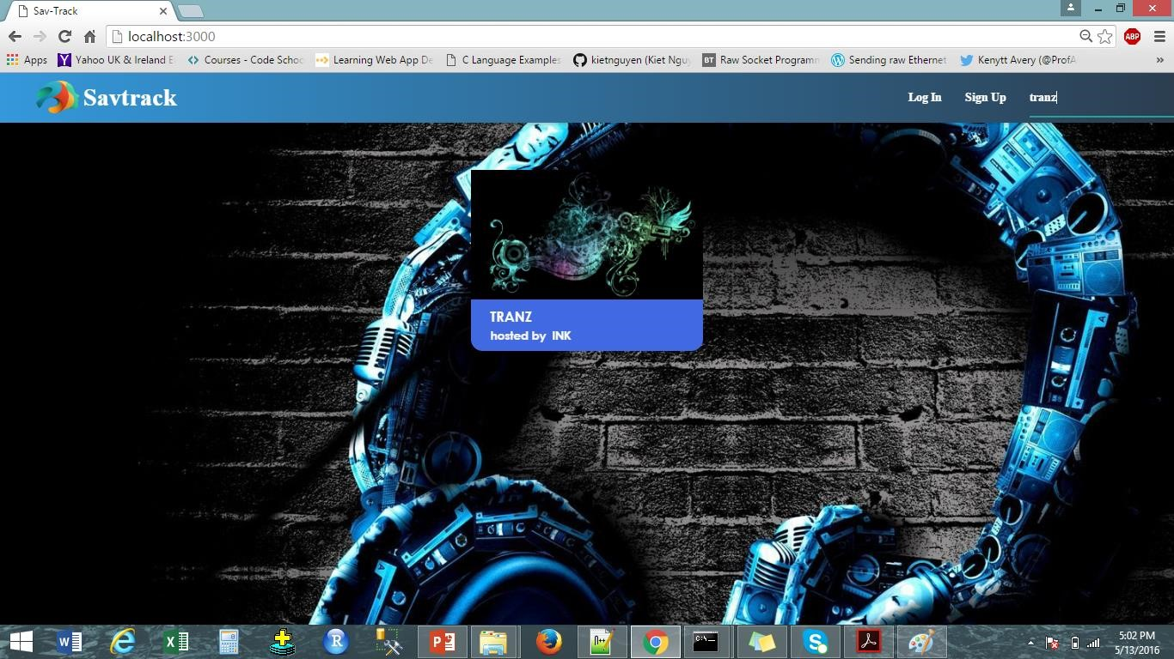

**Chat application:**

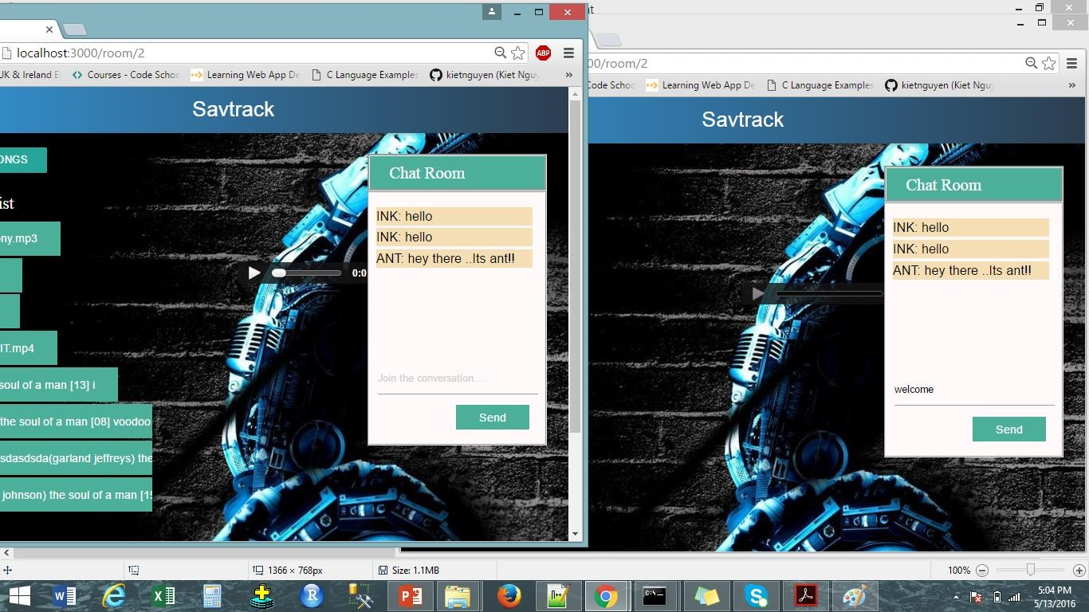

**Song Played**

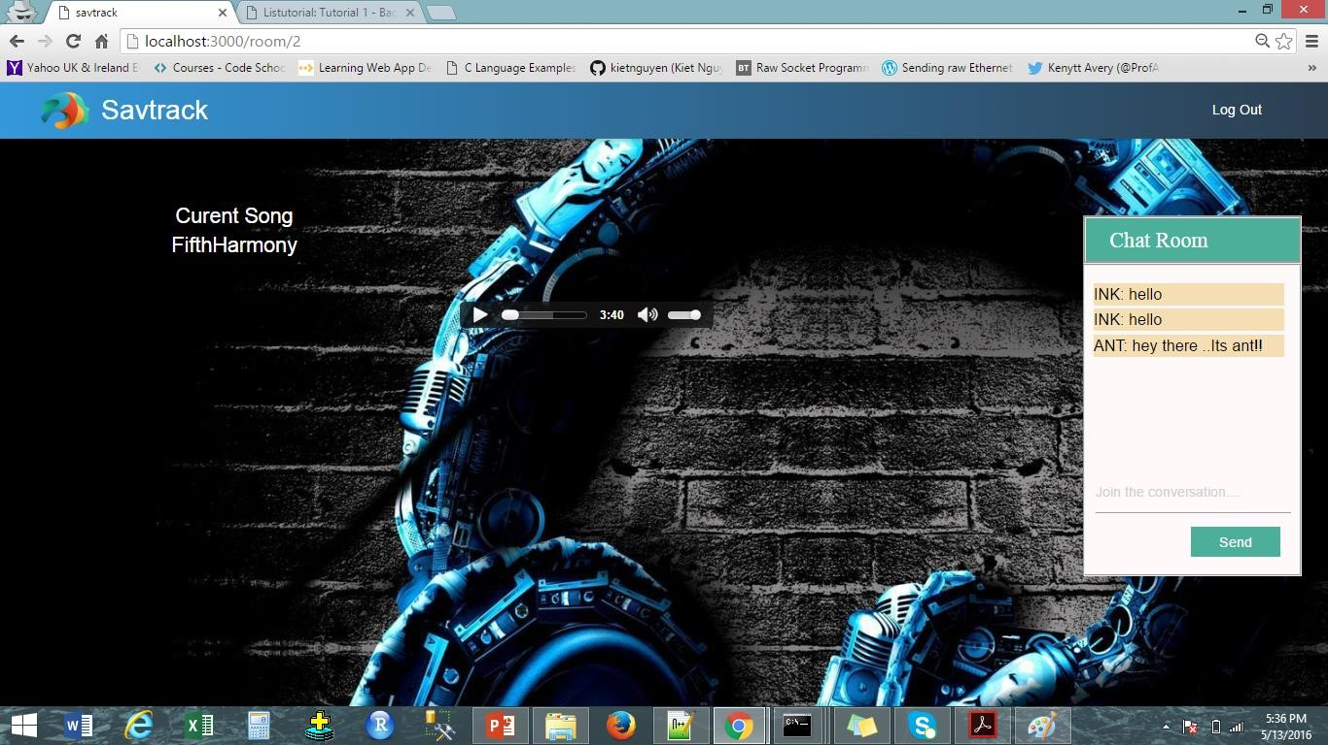

**Mongo Db Document showing the rooms collection:**

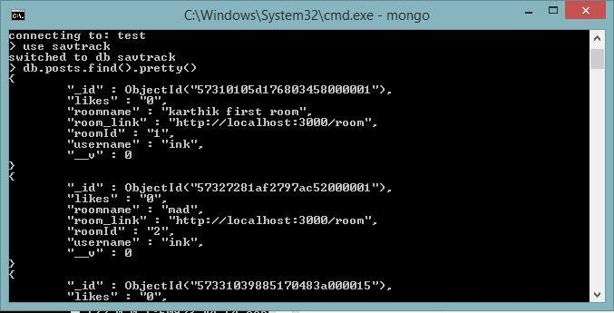

**Current song played in Non – owned Rooms**

